COVERING SHEET – INSTRUCTIONS

THIS COVERING SHEET MUST BE REMOVED BEFORE SENDING EASY READ QUESTIONNAIRE TO PATIENT.

The availability of the Easy Read questionnaire will be signposted on the mailing letters and administered at the request of the patient.
Once requested, the following steps should be taken.
Administering the request:
- Highlighted yellow text on pages 2 and 18 in this Easy Read booklet should be personalised. The booklet contains both the Easy Read cover letter and questionnaire.
- The booklet should be posted to the patient alongside a return envelope. You can either use the Freepost address you have set up or include a stamped addressed envelope to a different processing address.
- Please log any Easy Read requests as ER_Requested in the weekly monitoring fieldwork sheet.
- At the time of the patient requesting the Easy Read, if it’s likely they will receive a further mailing (e.g. due to mailing deadlines) it is worth making them aware this will happen, but that an Easy Read will also be sent to them.
- If the patient does not take part, the code should be left as ER_Requested in the separate column (excluded from response rate) and an outcome code of 6 or 4 added.
Processing the return:
- Manually enter responses into the excel data entry spreadsheet for Type 3 Easy Read questionnaire responses.
- In the main excel data entry spreadsheet for Type 3 (not the data entry spreadsheet for Easy Read returns) update the outcome to 1 (returned useable), then just leave the question responses blank.



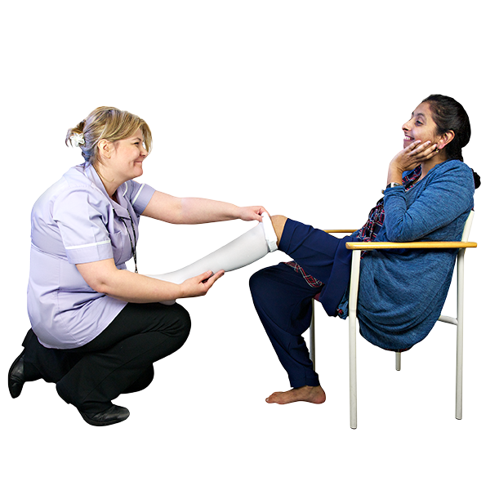
Survey number: | [INSERT HERE]

Please tell us about your last visit to the urgent care centre
2022

 | Easy read version of the Urgent and Emergency Care Survey 2022
 |  | About this booklet
 |  | We would like you to answer some questions about your last visit to the urgent care centre.
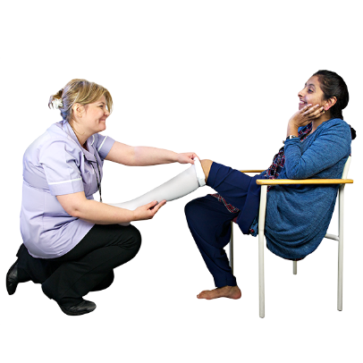 |  | You might go to an urgent care centre if you need medical help quickly, but it is not too serious. For more serious treatment you would go to A&E.
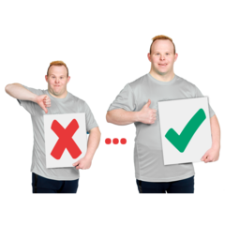 |  | Your answers will help urgent care centres improve their services for patients.
 |  | You can answer each question by putting a tick in the box next to the answer you want.
 |  | You can ask somebody to help you read the questions and answer them if you want.
 |  | But they should not tell you which answer to pick, because we want to know what you think.
 |  | You do not have to answer all the questions if you do not want to.
 |  | Your answers are private. We will not use your name when we share what we have found out from all the answers we receive.
 |  | Doctors and nurses
 |  | - How good were the doctors and nurses at listening to what you had to say?
 |  | ☐ Very good
 |  | ☐ Good
 |  | ☐ OK
 |  | ☐ Bad
 |  | ☐ Very bad
 |  | ☐ I do not know or cannot remember
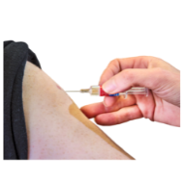   |  | - How good were the doctors and nurses at making you feel you could talk to them about your worries and fears?
 |  | ☐ Very good
 |  | ☐ Good
 |  | ☐ OK
 |  | ☐ Bad
 |  | ☐ Very bad
 |  | ☐ I do not know or cannot remember
 |  | - How good were the doctors and nurses at making you feel confident that you were being given the right treatment?
 |  | ☐ Very good
 |  | ☐ Good
 |  | ☐ OK
 |  | ☐ Bad
 |  | ☐ Very bad
 |  | ☐ I do not know or cannot remember

 | Your care and treatment
 | - How good were the doctors and nurses at helping you to take part in decisions about your care and treatment?
 | ☐ Very good
 | ☐ Good
 | ☐ OK
 | ☐ Bad
 | ☐ Very bad
 | ☐ I was not able to take part
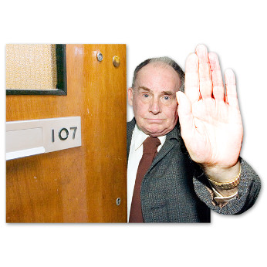 | ☐ I did not want to take part
 | ☐ I do not know or cannot remember
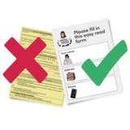 | - How good were the staff at supporting you to talk with them or getting you information in different ways to help you understand?  (This is support like British Sign Language interpreters or easy read.)
 | ☐ I did not need this
 | ☐ Very good
 | ☐ Good
 | ☐ OK
 | ☐ Bad
 | ☐ Very bad
 | ☐ I do not know or cannot remember
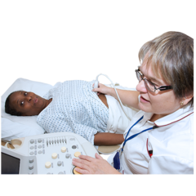 | - Think about when you were examined or treated at the urgent care centre. How good were the doctors and nurses at giving you enough privacy?
 | ☐ Very good
 | ☐ Good
 | ☐ OK
 | ☐ Bad
 | ☐ Very bad
 | ☐ I did not want this
 | ☐ I do not know or cannot remember
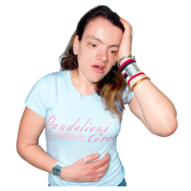 | - How good were the doctors and nurses at helping you when you felt in pain?
 | ☐ Very good
 | ☐ Good
 | ☐ OK
 | ☐ Bad
 | ☐ Very bad
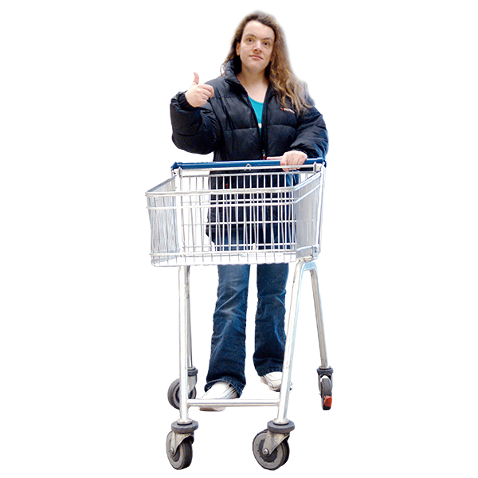 | ☐ I was not in pain
 | ☐ I do not know or cannot remember

 | Leaving the urgent care centre
 | - Think about before you left the urgent care centre. How good were the doctors and nurses at telling you how to care for yourself at home?
 | ☐ Very good
 | ☐ Good
 | ☐ OK
 | ☐ Bad
 | ☐ Very bad
 | ☐ I do not know or cannot remember
 | - Think about after you left the urgent care centre. How good were health or social care services at helping you with your health condition?
 | ☐ Very good
 | ☐ Good
 | ☐ OK
 | ☐ Bad
 | ☐ Very bad
 | ☐ I did not need help
 | ☐ I do not know or cannot remember
 | General questions
 | - In general, how good were the doctors and nurses at treating you with respect?
 | ☐ Very good
 | ☐ Good
 | ☐ OK
 | ☐ Bad
 | ☐ Very bad
 | ☐ I do not know or cannot remember
 | - In general, how good was your experience in the urgent care centre?
 | ☐ Very good
 | ☐ Good
 | ☐ OK
 | ☐ Bad
 | ☐ Very bad
 | ☐ I do not know or cannot remember
 | About you
 | - How would you describe yourself?
 | ☐ Male
 | ☐ Female
 | ☐ I do not want to say
 | ☐ Other (please write down how you would describe yourself below)
 | - How old are you? Please write your age in years below.
 | Anything else
 | - Is there anything else you would like to tell us about your experience in the urgent care centre? Please write it below.  We will take out any information that could identify you before making your answer public. But the hospital and the people (like CQC) you send these answers to will see your full answer. If your answer needs looking into, we may share it with the best person to help.
 | Thank you very much for answering these questions.
 | When we have looked at all the answers from everyone, we will write a report about what we found and put it on our website at: www.cqc.org.uk/surveys.
 | What to do with your answers
 | Please post your answers back in the FREEPOST envelope provided. No stamp is needed.
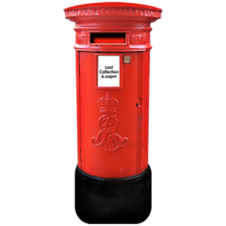 | If you do not have your FREEPOST envelope, please send your answers to <INSERT FREEPOST ADDRESS>

